

**Software Requirements Specification**

**Grocery Shop Management System**

**Project - ICT 3206**

**Bachelor of Information and Communication Technology**

**(BICT)**

**Degree Programme**

Department of Information and Communication Technology

Faculty of Technology

Rajarata University of Sri Lanka Mihintale

**Details of the Research Project**

Title : Grocery Shop Management System

Group Number : 01

Group Name : Techno

Submission Date : 13.07.2023

Group Members :

|  |  |  |
| --- | --- | --- |
| Student Name | Index Number | Signature |
| P.W.D.I.M Rodrigo | 1357 |  |
| H.M.M.A Herath | 1313 |  |
| G.P Rockshan | 1356 |  |
| P.H.M.T Perera | 1344 |  |
| A.R.M Najas | 1335 |  |

Internal supervisor

Name : Ms. Oshadhi Munasinghe

Designation : Lecturer ( Temporary)

Department : Information and Communication Technology

Email : okmunasi@tec.rjt.ac.lk

Signature : ________________ Date: _____________

**Table of Contents**

1 Introduction 5

2 Feasibility Study 6

2.1 Technical Feasibility 6

2.2 Economic Feasibility 6

2.3 Organizational Feasibility 6

3 Functional Requirements 7

3.1 Use Case Scenarios 8

3.2 Use Case Diagram 11

3.3 Activity Diagram 12

4 Non-Functional Requirements 13

4.1 Product requirements 13

4.1.1 Usability requirement 13

4.1.2 Efficiency requirement 13

4.1.3 Reliability requirement 13

4.1.4 Portability requirement 13

4.2 Organizational Requirements 13

4.2.1 Delivery Requirement 13

4.2.2 Implementation Requirement 13

4.2.3 Standard Requirement 13

4.3 External Requirements 14

4.3.1 Interoperability Requirement 14

4.3.2 Ethical Requirement 14

4.3.3 Legislative Requirements 14

5 Entity Relationship Diagram 15

6 Hardware Design 16

7 Reference 17

**List of Tables**

Table 1 Use Case Scenario 1 – Employee Sign-Up 8

Table 2 Use Case Scenario 2 – Employee Sign-In 8

Table 3 Use Case Scenario 3 - Search for Products 9

Table 4 Use Case Scenario 4 - View Product Details 9

Table 5 Use Case Scenario 5 – Admin 10

**List of Figure**

Figure 1 User Case Diagram 11

Figure 2 Activity Diagram - Placing Order 12

Figure 3 ER Diagram 15

# 1 Introduction

In the ever-evolving landscape of the retail industry, the effective management of grocery stores has become increasingly intricate and challenging. The surge in competition coupled with evolving customer expectations has exposed the limitations of manual inventory tracking, sales monitoring, and customer management techniques. The absence of a comprehensive Grocery Shop Management System (GSMS) tailored to the distinct needs of small- to medium-sized grocery stores has resulted in escalated expenses, operational inefficiencies, and compromised customer service quality.

Grocery store owners currently grapple with a myriad of challenges, including incomplete inventory records leading to stockouts or overstocking, a lack of understanding of consumer preferences and purchasing habits, and an absence of an efficient procedure for managing suppliers and procurement. Moreover, the absence of synergy between various operational components hampers decision-making processes, impeding the overall expansion and sustainability of grocery stores.

In light of these challenges, it is evident that a reliable and user-friendly grocery shop management system is imperative. Encompassing features such as real-time inventory management, sales analytics, customer relationship management, and seamless supplier connection, such a system should cater specifically to the nuanced needs of grocery stores. The effective deployment of a GSMS is anticipated to optimize day-to-day operations, fortify decision-making capabilities, enhance customer satisfaction, and ultimately bolster the long-term survival and viability of grocery stores in the fiercely competitive retail industry.

As a response to these imperatives, the goal of this project is to conceive, develop, and implement a successful grocery shop management system tailored to the unique requirements of supermarket retailers. The overarching objective is to cultivate heightened customer satisfaction, foster data-driven decision-making, and streamline operational efficiency. This project aspires to be a catalyst for grocery businesses, empowering them to thrive in a more competitive and sustainable environment through the progressive integration of technology solutions in the retail sector.

# 2 Feasibility Study

The feasibility study is a critical phase in the development of the Grocery Shop Management System (GSMS), aiming to provide a comprehensive understanding of the practicality and viability of implementing the system. This study is divided into three key components.

## 2.1 Technical Feasibility

The technical feasibility assessment focuses on evaluating the practicality and viability of implementing the GSMS from a technological standpoint. It involves an in-depth analysis of the existing technical infrastructure, potential technological challenges, and the compatibility of the proposed system with current hardware and software. Technical feasibility will explore the capability of the GSMS to seamlessly integrate with modern technologies, such as real-time inventory tracking, sales analytics, and customer relationship management tools. The study aims to ensure that the proposed system is technically robust, scalable, and capable of meeting the dynamic needs of grocery stores.

## 2.2 Economic Feasibility

Economic feasibility is a crucial aspect that delves into the financial viability of implementing the GSMS. This assessment involves a thorough examination of the costs associated with the development, deployment, and maintenance of the system. Factors such as software and hardware expenses, labor costs, training, and potential savings or revenue generation will be scrutinized. The economic feasibility study aims to provide insights into the financial implications of adopting the GSMS, determining whether the benefits derived from the system justify the investment, and ensuring a positive return on investment for grocery store owners.

## 2.3 Organizational Feasibility

The organizational feasibility component evaluates the readiness and adaptability of the grocery stores to implement the GSMS. This assessment encompasses an analysis of the organizational structure, the level of support from management and staff, and the willingness to embrace technological changes. It also considers the potential impact on daily operations, employee roles, and the overall organizational culture. The organizational feasibility study aims to ascertain whether the implementation of the GSMS aligns with the strategic goals and operational capabilities of the grocery stores, ensuring a smooth integration that enhances rather than disrupts organizational dynamics.

# 3 Functional Requirements

A Grocery Management System involves various functionalities to efficiently handle the processes associated with managing a grocery store.

* Product Management

Add, edit, and delete grocery items in the inventory. Assign categories and tags to products for easy classification. Manage product details such as price, quantity, and expiration dates.

* Inventory Management:

Set up notifications for low stock levels. Generate reports on inventory status and trends.

* Order Management

Allow customers to place orders in-store. Process and manage customer orders. Update order.

* Supplier Management

Maintain a list of suppliers and their contact information. Track supplier deliveries and update inventory accordingly. Manage supplier payments and invoices.

* Employee Management

Create and manage employee profiles with access levels. Track working hours and shifts. Assign roles such as cashier, stock clerk, or manager.

* Sales and Billing

Generate receipts and invoices for customer purchases. Accept multiple payment methods (cash, credit card, mobile payments).Provide discounts, promotions, and loyalty programs.

* Customer Management

Maintain a database of customer profiles. Track purchase history and preferences. Implement a customer loyalty program.

* Reporting and Analytics

Generate sales reports, profit and loss statements, and inventory reports. Provide insights into popular products and customer behavior. Support customizable reporting based on specific business needs.

* Security and Access Control

Implement user authentication and authorization. Define roles and permissions for different system users. Ensure data privacy and compliance with relevant regulations.

* Barcode Scanning

Support barcode scanning for quick and accurate product identification. Integrate with barcode scanners or mobile devices for efficient inventory management.

* Integration with Accounting Systems

Integrate with accounting software for seamless financial management. Automatically update financial records based on sales and expenses.

* Feedback and Review System

Allow customers to provide feedback and reviews. Monitor and respond to customer feedback for continuous improvement.

## 3.1 Use Case Scenarios

Table 1 Use Case Scenario 1 – Employee Sign-Up

|  |  |  |
| --- | --- | --- |
| Use Case Name |  | Sign-Up |
| Primary Actor |  | Admin |
| Pre-Condition |  | Admin is sign-in to the system |
| Post-Condition |  | Successfully sign-up to the system |
| **Main Success Scenario** | **Serial No.** | **Step** |
|  | 1 | Admin enters required Employee details |
| 2 | Validate the details |
| 3 | Allow access to system |

Table 2 Use Case Scenario 2 – Employee Sign-In

|  |  |  |
| --- | --- | --- |
| Use Case Name |  | Sign-In |
| Primary Actor |  | Employee |
| Pre-Condition |  | Employee sign-up on the system |
| Post-Condition |  | Successfully sign-in to the system |
| **Main Success Scenario** | **Serial No.** | **Step** |
|  | 1 | User enters user name and password |
| 2 | Validate the user name and password |
| 3 | Allow access to system |

|  |  |  |
| --- | --- | --- |
| Use Case Name |  | Search for Products |
| Primary Actor |  | Employee |
| Pre-Condition |  | Employee sign-in to the system |
| Post-Condition |  | List of sorted products is displayed |
| **Main Success Scenario** | **Serial No.** | **Step** |
|  | 1 | User enters the desired search query. |
| 2 | The system retrieves relevant products. |
| 3 | The system displays the sorted list of products to the user. |

Table 3 Use Case Scenario 3 - Search for Products

Table 4 Use Case Scenario 4 - View Product Details

|  |  |  |  |  |  |
| --- | --- | --- | --- | --- | --- |
| Use Case Name | |  | | View Product Details | |
| Primary Actor | |  | | Employee | |
| Pre-Condition | |  | | Employee has searched for products and a list of results is displayed | |
| Post-Condition | |  | | Employee views the details of a selected of a selected product and get a link to the product buying page | |
| **Main Success Scenario** | | **Serial No.** | | **Step** | |
|  | | 1 | | User selects a product from the search results. | |
| 2 | | The system displays detailed information about the selected product, including images, descriptions, price, and reviews. | |
| 3 | | The system provides a link to the product buying page on the respective e-commerce platform. | |
| **Alternative Scenarios** | | **Serial No.** | | **Step** | |
| If no relevant products are found for the user's search query: | | 1 | | The system displays a message indicating that no products match the search criteria. | |
| 2 | | The user can refine the search query or try a different search term | |

|  |  |  |
| --- | --- | --- |
| Use Case Name | | Administrator Use Case |
| Description | | Administrator have control over system configurations, product management and user accounts. |
| Actors | | Customer  System |
| Use Cases | | Manage products.  Add/remove products.  View sales reports.  Manage user accounts.  Configure system settings. |
| **Use Case Scenarios** | **Serial No** | **Steps** |
| Administrator adds a new product. | 1 | 1 - Administrator accesses the product management section.  2 - Administrator adds a new product with details.  3 - System updates the product database. |
| Administrator views sales reports. | 2 | 1 - Administrator navigates to the sales reports section.  2 - System generates and displays sales reports for a specific time period. |
| **Alternative Scenarios** | **Serial No** | **Steps** |
| Administrator removes a product. | 1 | 1 - Administrator selects a product to remove.  2 - Administrator confirms the removal.  3 - System updates the product database. |

Table 5 Use Case Scenario 5 – Admin

## 3.2 Use Case Diagram

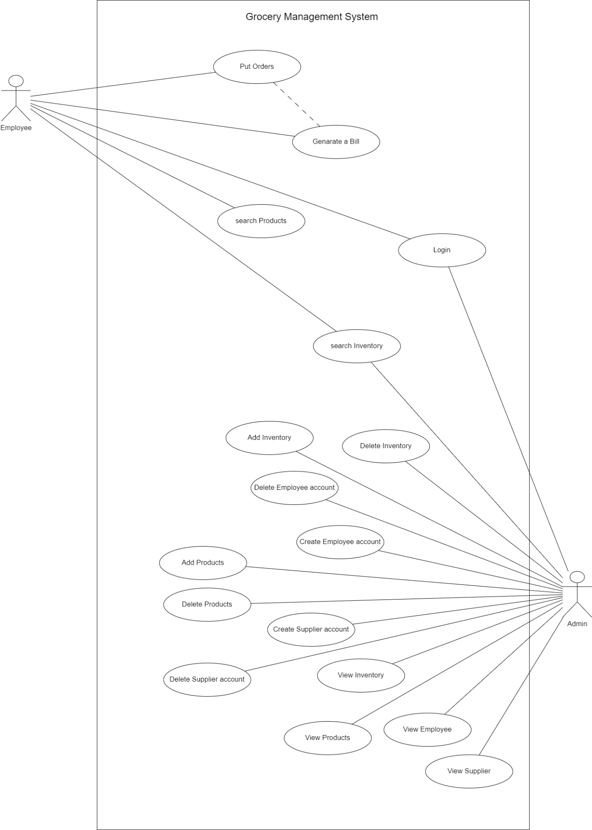

Figure 1 User Case Diagram

## 3.3 Activity Diagram

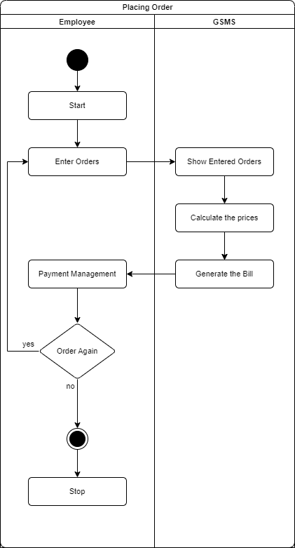

Figure 2 Activity Diagram - Placing Order

# 4 Non-Functional Requirements

## **4.1** **Product requirements**

### 4.1.1 Usability requirement

* + - The system must have an intuitive and user-friendly interface for both Employee and administrators.
    - Response times for user interactions should be quick, maintaining a smooth user experience.

### 4.1.2 Efficiency requirement

#### Performance requirements

* + - * The system must handle concurrent user interactions efficiently, supporting multiple users simultaneously.
      * Response time for processing transactions and generating reports should be within acceptable limits.

#### space requirements

* + The system should efficiently utilize storage space for product information, user data, and transaction records.
  + Data compression techniques should be employed to minimize storage requirements.

### 4.1.3 Reliability requirement

* The system must ensure high availability, aiming for at least 99% uptime.
* Prevent data loss by maintaining data integrity and implementing backup systems.

### 4.1.4 Portability requirement

* Ensure system accessibility and responsiveness across several platforms, such as computers, tablets, and smartphones.
* Ensure compatibility with popular web browsers including Chrome, Firefox, and Safari.

## 4.2 Organizational Requirements

### 4.2.1 Delivery Requirement

* The system must be delivered and implemented within the agreed-upon timeline.
* Regular updates and maintenance releases should be delivered to address any issues and introduce new features.

### 4.2.2 Implementation Requirement

* The implementation process must be seamless, with minimal disruption to existing store operations.
* Adequate training and documentation should be provided for administrators and employees.

### 4.2.3 Standard Requirement

* The system must comply with industry standards for secure online transactions.
* Adherence to coding standards and best practices in software development is mandatory.

## 4.3 External Requirements

### 4.3.1 Interoperability Requirement

* The system should integrate with external systems, including payment gateways and inventory management applications.
* Use APIs and established data formats to ensure smooth integration.

### 4.3.2 Ethical Requirement

* The system must adhere to ethical data handling and user privacy standards.
* Encrypt and securely store customer data to prevent unwanted access.

### 4.3.3 Legislative Requirements

#### 4.3.3.1 Privacy Requirements

* The system must follow privacy regulations to protect client information.
* Implement user consent procedures for data collection and processing.

#### 4.3.3.2 Safety Requirements

* The system should incorporate safety measures to prevent unauthorized access and potential misuse.
* Regular security audits and vulnerability assessments must be conducted.

# 5 Entity Relationship Diagram

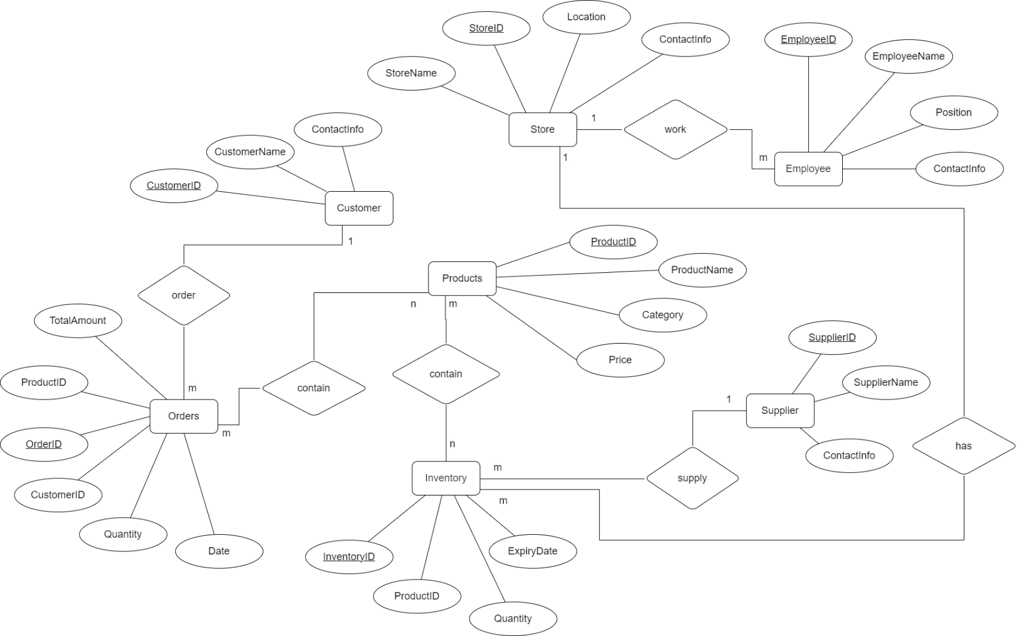

Figure 3 ER Diagram

# 6 Hardware Design

**Server:**

* Processor: 1 or 2 core processor with more than 1Ghz
* Storage: SSD attest 25GB

**Client Devices:**

* Processor: 1Ghz or faster processor
* RAM: 2 GB- 8GB
* Display: 720p or better resolution display

**Optical Peripheral Devices:**

* Barcode Reader
* Point Of Sale (POS) Machine
* Receipt Printers
* Cash Registers

**Backup and Storage:**

* Backup Frequency: Daily backups of database
* Cache storage

# 7 Reference

1. **Studocu - Grocery Management System Mini Project**
   * URL:<https://www.studocu.com/in/document/jawaharlal-nehru-technological-university-hyderabad/web-technologies/grocery-management-system-mini-proj/42132608>
2. **ResearchGate - Online Grocery Management System**
   * URL:<http://www.researchgate.net/publication/352477571_ONLINE_GROCERY_MANAGEMENT_SYSTEM>
3. **IEEE Citation Style Guide**
   * URL:<https://ieee-dataport.org/sites/default/files/documents/ieee_reference_guide.pdf>
4. **Software Engineering: A Practitioner's Approach (7th Edition)**
   * Author: Roger S. Pressman
   * URL:<https://www.amazon.com/Software-Engineering-Practitioners-Roger-Pressman/dp/0078022126>
5. <https://www.studocu.com/in/document/jawaharlal-nehru-technological-university-hyderabad/webtechnologies/grocery-management-system-mini-proj/42132608>